Lab 3 screenshots – Hassan Ihsan

A screenshot of the inputs prior to clicking Calculate

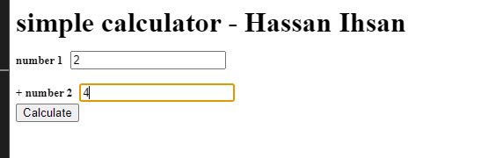

A screenshot of the output after clicking Calculate

